## 题目：

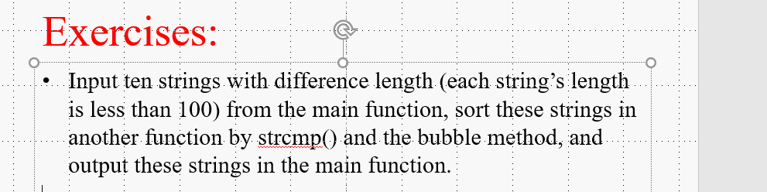

## 源代码：

#include <stdio.h>

#include <stdlib.h>

#include <string.h>

void sort(char *array[]);

int main()

{

char *arr[10]; //定义一个指针数组，数组中的每一个元素都是指针；

int i; //定义一个int类型的过程变量；

for (i=0;i<10;i++)

{

printf("请输入第%d个字符串：", i + 1);

arr[i] = (char *)malloc(100 * sizeof(char)); //输入前设置指针变量的内存空间为100位；

scanf("%s", arr[i]); //在这个指针的内存上输入字符串；

}

sort(arr); //把输入好的字符串以地址的形式传入sort函数；

printf("\n\n排序后的字符串：\n"); //输出字符串；

for (i = 0; i < 10; i++)

{

printf("%d: %s\n", i + 1, (char *)arr[i]); //把指针强制转化为字符串类型；

}

return 0;

}

void sort(char *array[]) //定义一个指针数组，用来存传过来arr的地址；

{

char *temp_p; //定义一个过程的指针变量；

int i, j, count = 10; //定义循环变量i，j，和计数变量count为10；

//冒泡排序；

for (i = 0; i < count-1; i++)

{

for (j = 0; j < count-i-1; j++)

{

if (strcmp(array[j], array[j+1]) > 0) //通过指针调用所存字符串，并来比较大小；

{

temp_p = array[j];

array[j] = array[j+1];

array[j+1] = temp_p;

}

}

}

}

## 输出结果：

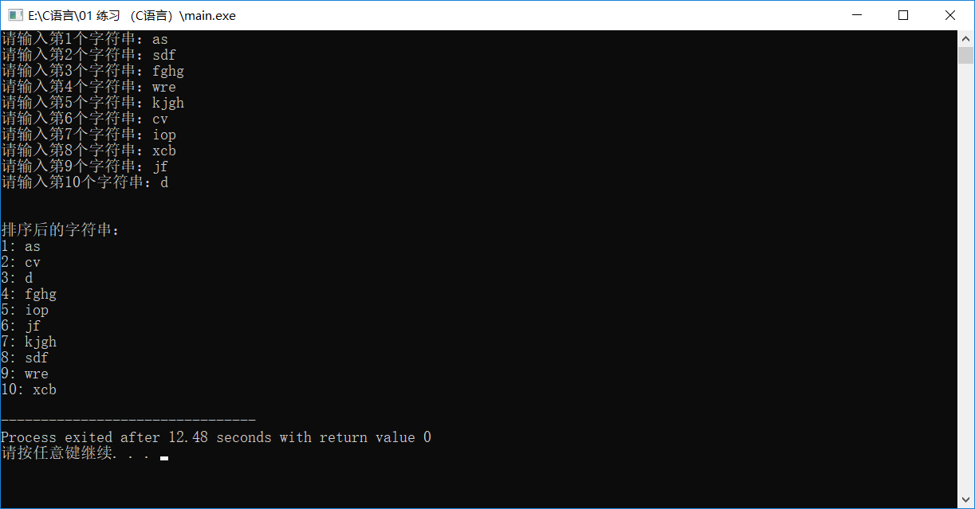

## 题目：指针复制字符串

## 源代码：

#include <stdio.h>

#include <string.h>

int main()

{

char arr[100], copy_arr[100]; //定义输入数组，以及复制数组；

char *ip, *temp; //定义数组指针变量，和过程指针变量；

int m; //从第m位开始复制；

printf("请输入字符串：");

scanf("%s", &arr); //输入数组，并通过指针存入arr【】；

printf("从第m位开始复制：");

scanf("%d", &m);

m = m - 1; //从第m位复制，包含第m位；

ip = copy_arr; //把copy_arr的首位地址存入ip；

for (temp = arr + m; temp < arr + strlen(arr); temp++) //遍历原数组，从第m位开始，到首位+长度结束，temp为过程量；

{

*ip = *temp; //遍历原数组的过程元素存入ip的地址，即为新数组；

ip++; //每次循环，ip加一，新数组后移一位；

}

for (temp = copy_arr; temp < copy_arr + strlen(copy_arr); temp++) //遍历新数组，从第1位开始，到首位+长度结束，temp为过程量；

{

printf("%c",*temp); //输出过程量所对应的元素；

}

return 0;

}

## 输出结果：

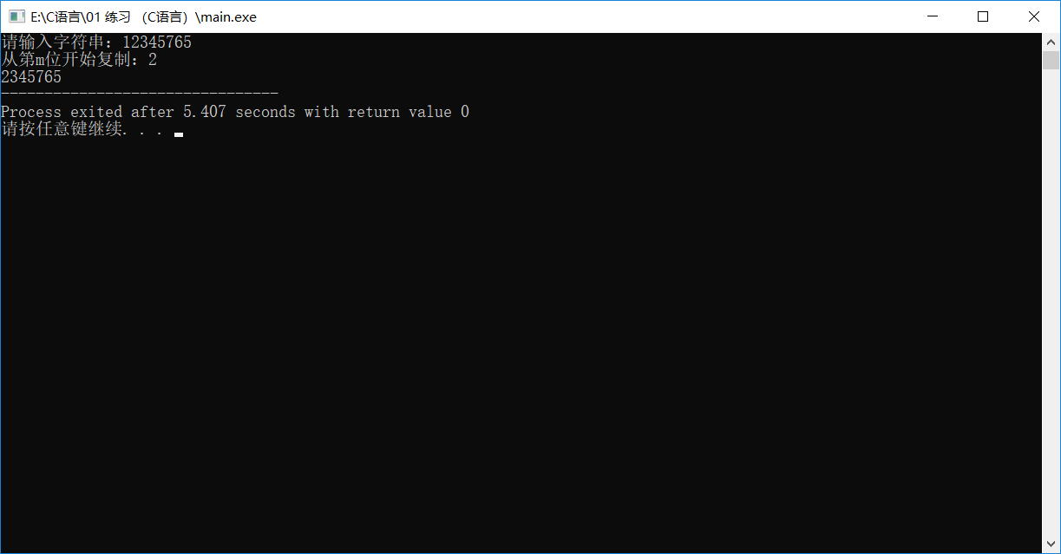

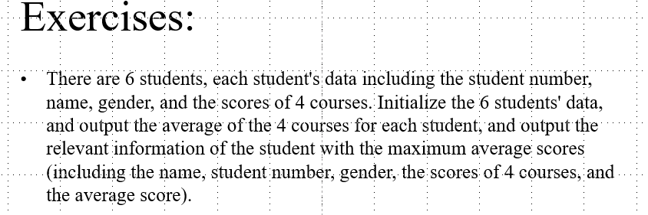

## 源代码：

#include <stdio.h>

int main()

{

struct student

{

char student_number[10];

char name[10];

char gender[10];

int course_1;

int course_2;

int course_3;

int course_4;

double average;

};

int i, j;

struct student tmp;

struct student student_data[4] = { {"111","a","男",90,90,90,90,0}, {"222","b","男",91,91,91,91,0},{"333","c","女",93,93,93,93,93},{"444","d","男",87,87,87,76,0} };

for (i = 1; i <= 4; i++) //输入四名同学的信息

{

printf("请输入student_%d的信息：\n",i);

printf("Student_number: ");

scanf("%s", &student_data[i].student_number);

printf("Name: ");

scanf("%s", &student_data[i].name);

printf("Gender: ");

scanf("%s", &student_data[i].gender);

printf("Course_1: ");

scanf("%d", &student_data[i].course_1);

printf("Course_2: ");

scanf("%d", &student_data[i].course_2);

printf("Course_3: ");

scanf("%d", &student_data[i].course_3);

printf("Course_4: ");

scanf("%d", &student_data[i].course_4);

//计算平均成绩

student_data[i].average = (student_data[i].course_1 + student_data[i].course_2 + student_data[i].course_3 + student_data[i].course_4) / 4;

}

for (i = 1; i < 4; i++) //冒泡法对平均成绩进行排序

{

for (j = 0; j < 4 - i; j++)

{

if (student_data[j].average > student_data[j + 1].average)

{

tmp = student_data[j];

student_data[j] = student_data[j + 1];

student_data[j + 1] = tmp;

}

}

}

printf("\n平均成绩最好的同学是："); //输出成绩最好的同学的信息

printf("\nStudent_number: %s",student_data[3].student_number);

printf("\nName: %s",student_data[3].name);

printf("\nGender: %s",student_data[3].gender);

printf("\nCourse_1: %d", student_data[3].course_1);

printf("\nCourse_2: %d", student_data[3].course_2);

printf("\nCourse_3: %d", student_data[3].course_3);

printf("\nCourse_4: %d", student_data[3].course_4);

printf("\nAverage: %.3lf", student_data[3].average);

return 0;

}

## 输出结果：

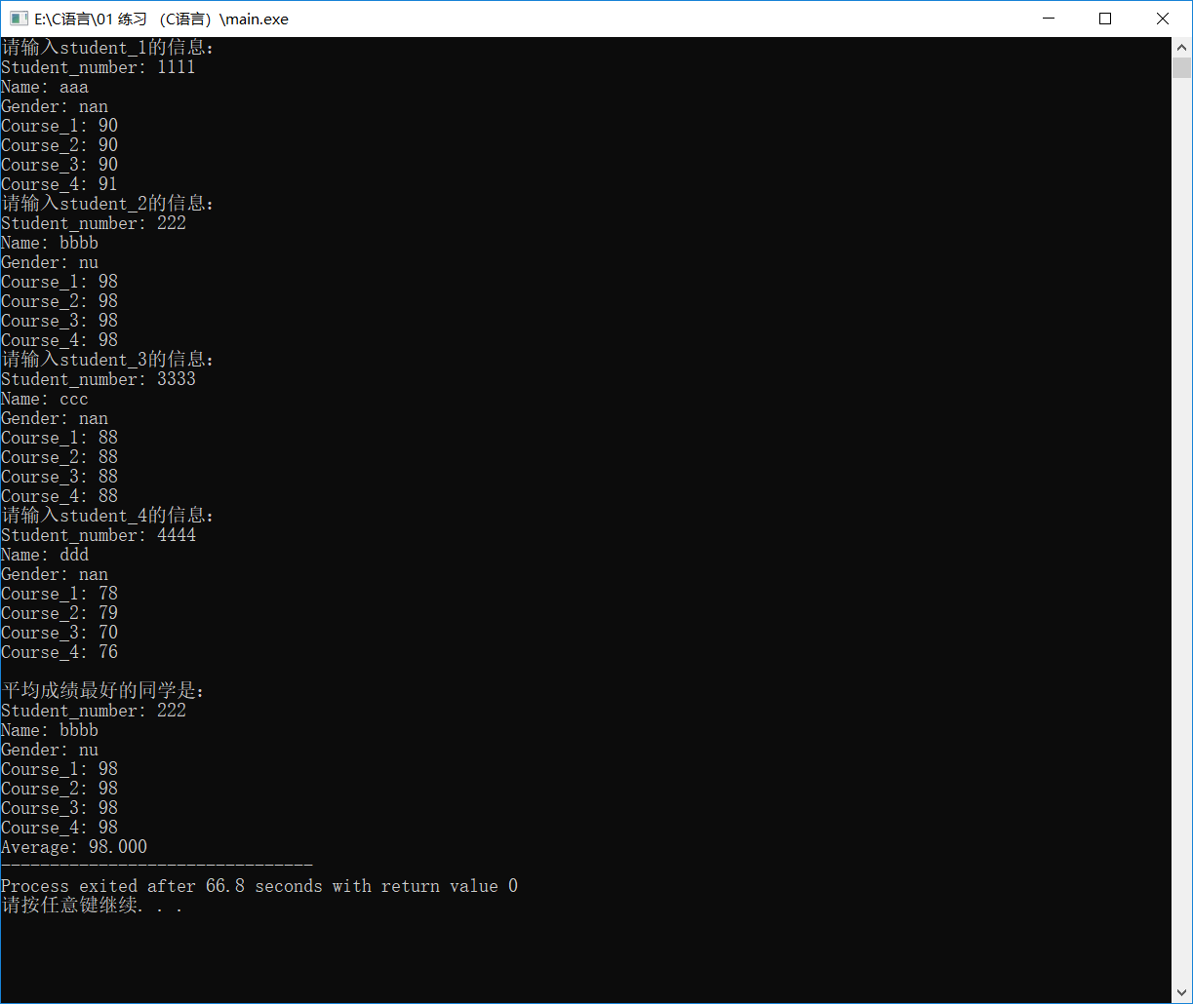

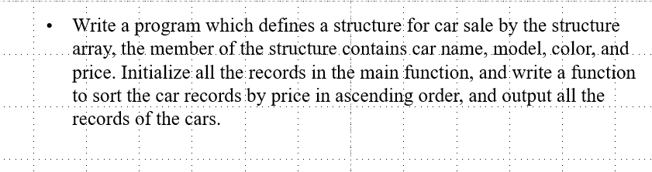

## 源代码：

#include <stdio.h>

struct car

{

char car_name[15];

char model[10];

char color[10];

double price;

};

void sort(struct car car_data[]);

int main()

{

int i, j;

//struct car tmp; //过程交换结构体

struct car car_data[4] = { {"Benz","a","银色",100}, {"Audi","b","黑色",120},{"Volkswagen","c","红色",53},{"Jeep","d","白色",99} };

/*

for (i = 1; i <= 4; i++) //输入车的信息

{

printf("请输入第%d辆车的信息：\n", i);

printf("Car Name: ");

scanf("%s", &car_data[i].car_name);

printf("Model: ");

scanf("%s", &car_data[i].model);

printf("Color: ");

scanf("%s", &car_data[i].color);

printf("Price: ");

scanf("%lf", &car_data[i].price);

}

*/

sort(car_data);

for (i = 0; i < 4; i++) //输出按价格排序输出

{

printf("\n第%d贵的车是：",i+1);

printf("\nCar Name: %s", car_data[i].car_name);

printf("\nModel: %s", car_data[i].model);

printf("\nColor: %s", car_data[i].color);

printf("\nPrice: %.1lf万元\n", car_data[i].price);

}

return 0;

}

void sort(struct car car_data[])

{

int i, j;

struct car tmp; //过程交换结构体

for (i = 1; i < 4; i++) //冒泡法对价格进行排序

{

for (j = 0; j < 4 - i; j++)

{

if (car_data[j].price < car_data[j + 1].price)

{

tmp = car_data[j];

car_data[j] = car_data[j + 1];

car_data[j + 1] = tmp;

}

}

}

## }输出结果：

